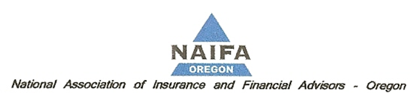
NAIFA Position for SB 95
- SB 95 should be a bill for voluntary reporting of financial exploitation. With that in mind the following changes are recommended:
  - The bill should create an easy to use system for reporting to DCBS.
  - Training on how to detect and report financial exploitation should be required for first time licensing.
  - Training on how to detect and report financial exploitation should be required as continuing education to maintain licenses.
  - Potential conflicts with new DOL rules need to be considered and worked out.
  - Companies could be required to report instead of individuals.

- If the SB95 is to remain a mandatory reporting bill, the following issues should be considered and amendments to the bill to address these issues adopted.
  - Training of qualified individuals will be required so that they will understand the new requirements.
    - The implementation date for the bill should be delayed until January 2019 to allow for curriculum development.
    - No penalties should be imposed until January 2020 to allow time for agents to be trained in recognizing and reporting suspected elder abuse.
  - Federal DOL rules may conflict with the bill as drafted. The bill must show how qualified individuals are to comply with any conflicting rules.

- Specific, Section by Section issues.
  - Section 1
    - (2)(b) person with disability definition should be changed to ORS 410.040(7) and ORS 410.715
    - (3) Does this definition include a situation when someone is “taking advantage” of a family member with the person’s consent? If so, that should be changed.
    - (3)(b) “omission” should not be included
  - Section 2
    - Is “reasonable cause” the correct evidentiary standard to use?
    - “shall promptly notify” needs a definition.
    - The reporting requirement in should be changed to a single agency, in writing and the agency must be DCBS.
    - (2) Includes “must” and “if known”. This creates confusion and is potential trap for qualified individuals.
  - Section 4
    - How is the qualified individual to know who may be the “…third party that is suspected of actual or attempted financial exploitation or other abuse.”
  - Section 6
    - (1)(b)(A) What if the only party authorized to transact business is the party suspected of exploitation?
    - (1)(b)(B) Reporting only to DCBS.
    - (1)(b)(C) This section requires companies to become investigators. They may not be experts in this area. Also any reporting should only be to DCBS.

  - Section 9
    - The enforcement should be only by DCBS.

